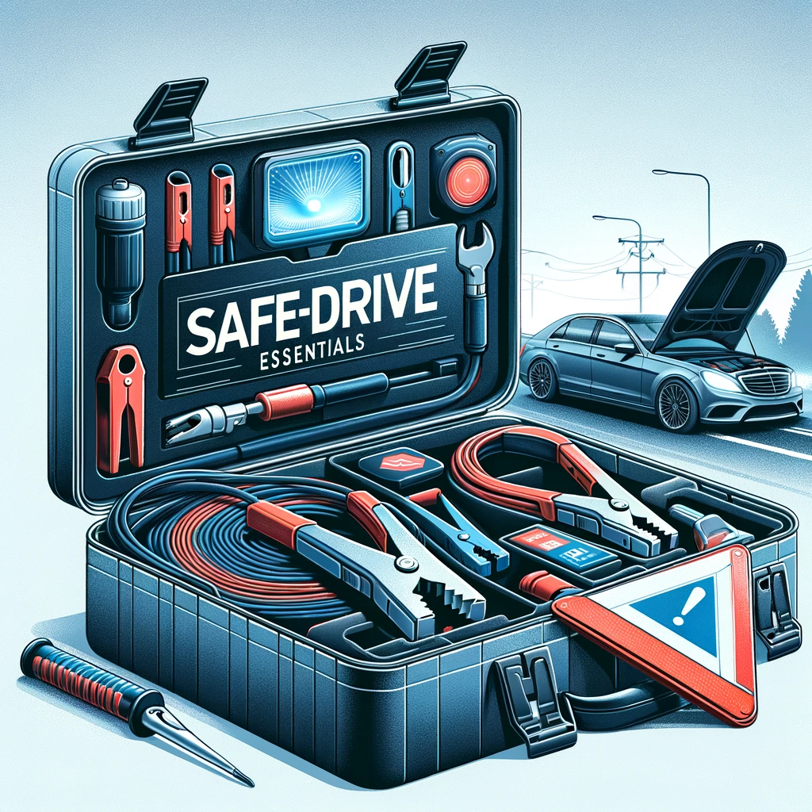

**Table of Contents**

* **Background**
* **Objective**
* **Problem Scenario**
* **Data Extraction/Collection/Scraping**
* **Data Visualization and Analysis:**
* **Conclusion**
* **Recommendation**
* **Reference**

Startup Background:

I founded SafeDrive Essentials with a mission to provide drivers with comprehensive roadside emergency kits, ensuring safety, convenience, and peace of mind during unexpected vehicular situations. The growing demand for vehicle safety products, coupled with an increasing emphasis on preparedness, presented an opportunity to serve a market seeking reliable, all-in-one solutions for roadside emergencies.

Our product line includes compact, durable emergency kits containing essential items such as jumper cables, a safety hammer, a reflective triangle, and other rescue tools. These kits are designed to be easily storable in a vehicle and readily accessible in emergencies.

What sets SafeDrive Essentials apart is the quality of its products, with high-quality, durable components that meet safety standards, coupled with compact, functional packaging that ensures easy storage. Our cohesive brand identity includes a strong digital presence and content marketing strategy that educates and engages customers on vehicle safety.

Distribution channels include online availability, partnerships with auto shops and retailers, and direct sales through automotive shows and fairs. SafeDrive Essentials aims to scale by introducing new products, expanding into international markets, and forging partnerships with insurance companies and auto clubs to offer bundled services.

Objective:

SafeDrive Essentials aims to provide comprehensive roadside emergency kits that ensure the safety and preparedness of drivers in unexpected vehicular situations. Our goal is to offer high-quality, all-in-one solutions that meet safety standards, are easily storable in any vehicle, and are accessible to drivers globally. By combining product quality, functional design, and educational content, SafeDrive Essentials seeks to empower drivers to travel with confidence and peace of mind, knowing they are prepared for any emergency on the road.

Problem Scenario:

Imagine you’re driving late at night on a quiet highway, miles away from the nearest town. The road is dark, and your vehicle suddenly comes to a halt due to a mechanical issue. You’re stranded, with no immediate assistance in sight. You reach for your phone, but there’s no service to call for help. In such a scenario, having a comprehensive roadside emergency kit becomes essential.

A kit with jumper cables, a reflective warning triangle, a safety hammer, and other crucial tools can make the difference between waiting helplessly and taking control of the situation. The reflective triangle can alert passing drivers to your presence, reducing the risk of further incidents. A set of tools can assist with basic repairs, potentially getting you back on the road. In dire situations, these tools can also aid in escaping the vehicle, ensuring safety for both you and your passengers.

This scenario illustrates the real need for SafeDrive Essentials: a reliable, all-in-one solution that empowers drivers to handle unexpected vehicular emergencies, reducing stress and potential danger.

Data Extraction/Collection/Scraping:

To gather insights for SafeDrive Essentials, I leveraged data from an Amazon listing for a similar roadside emergency kit product. The aim was to understand market trends, customer feedback, and competitor positioning.

Steps Undertaken:

Web Scraping: Using Python, I wrote a web scraping script to extract key information from the Amazon listing. This script retrieved the product’s name, price, and customer reviews.

Product Details: The extracted information included the product name, “Car Roadside Emergency Kit, Auto Vehicle Safety Emergency Road Side Assistance Kits Essentials,” and its price, providing insight into how similar products are positioned in terms of naming, branding, and pricing.

Customer Reviews: The script also collected customer reviews, including ratings and textual content, allowing me to gauge overall satisfaction and identify common themes.

Sentiment Analysis: The textual reviews were preprocessed and analyzed for sentiment polarity, revealing the overall positive or negative feelings toward the product. This helped in understanding customer satisfaction and expectations.

Competitor Analysis: By analyzing the extracted data, I could benchmark SafeDrive Essentials against an existing product. The reviews highlighted areas of success, such as durability and completeness, and potential gaps, such as usability or design, guiding the development and positioning of my own product.

Insights and Implementation:

This example demonstrates how web scraping and data analysis can provide valuable insights into a product’s performance, market positioning, and customer sentiment:

Product Design: Feedback from reviews informs the design of SafeDrive Essentials, ensuring it includes comprehensive, high-quality items.

Pricing Strategy: The price point comparison helps position SafeDrive Essentials competitively in the market.

Brand Identity: The competitor’s name and branding strategy highlight the importance of cohesive naming and marketing for SafeDrive Essentials.

In conclusion, leveraging web scraping and data analysis provides crucial insights that guide product development, branding, and market positioning, ensuring SafeDrive Essentials effectively serves its target market.

Data Exploration/Data Visualization and Analysis :

To explore and visualize the data collected from the Amazon listing, I employed a series of tactics aimed at uncovering valuable insights and presenting them in a meaningful way. Here's a breakdown of the approaches taken:

Data Preparation:

The collected data, including product details and reviews, was organized into a structured dataset. This included columns for product name, price, review text, rating, processed review content, sentiment polarity, and numeric rating.

Textual reviews were preprocessed by removing stopwords, lowercasing, and tokenizing, making them suitable for analysis.

Sentiment Analysis:

Each review's processed text was analyzed for sentiment polarity, producing a score between -1 (negative) and 1 (positive). This allowed for quantifying customer satisfaction and providing a numerical representation of each review's sentiment.

These scores were then used for further exploration and visualization.

Rating Distribution:

The distribution of numerical ratings was visualized using a histogram, illustrating the overall satisfaction levels of customers. This provided insight into how many reviews fell into each rating category, from 1 to 5 stars.

Sentiment Distribution:

A histogram of sentiment polarity scores was created to show the distribution of positive, neutral, and negative sentiments among the reviews. This offered a comprehensive view of how customers felt about the product beyond numeric ratings.

Correlation Between Rating and Sentiment:

A scatterplot was generated to explore the relationship between numerical ratings and sentiment scores. This visualization helped to understand how closely aligned numeric ratings were to the sentiment expressed in review text, revealing potential discrepancies or consistencies.

Word Cloud:

A word cloud was generated from the processed review texts, highlighting frequently mentioned terms. This visual representation provided insight into common themes and topics discussed by customers, aiding in identifying key features or areas of concern.

Time Series Analysis:

A time series analysis tracked the trend of reviews over time, illustrating the volume of reviews per month. This visualization helped identify seasonal trends or shifts in customer engagement, offering potential insights into marketing strategies.

Feature Extraction:

By analyzing the review texts, frequently mentioned features such as "price," "quality," and "usability" were identified and ranked by popularity. This helped understand what aspects customers valued or criticized, guiding product development and marketing efforts.

Google Trends :

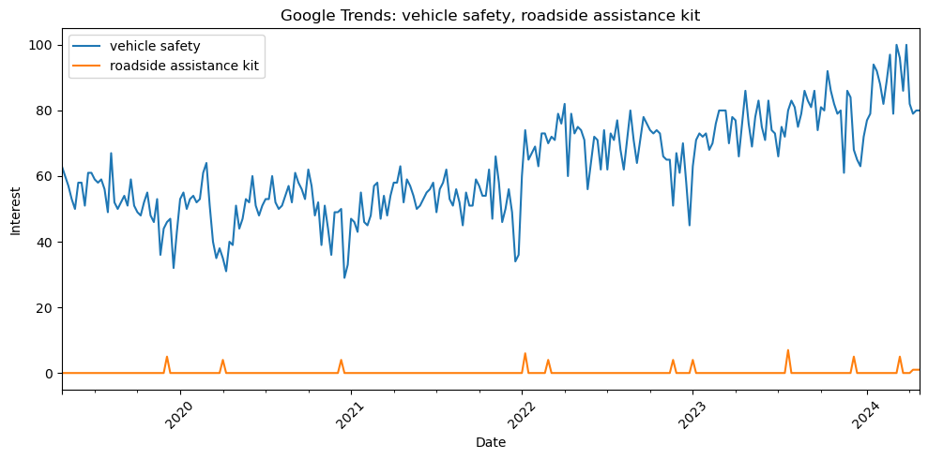

Graph Overview:

Title: "Google Trends: vehicle safety, roadside assistance kit"

X-axis: "Date" – This represents the time range, spanning from 2019 to 2024.

Y-axis: "Interest" – This measures the search interest level on a scale of 0 to 100, with 100 representing the peak interest for a specific search term.

Lines:

Blue Line: Represents search interest in the term "vehicle safety."

Orange Line: Represents search interest in the term "roadside assistance kit."

Analysis:

Vehicle Safety Trend:

The blue line shows consistent search interest for "vehicle safety," with noticeable fluctuations over time.

The trend shows an increase in search interest starting around 2022 and maintaining higher levels into 2024.

This indicates a growing awareness or concern for vehicle safety, which aligns with the mission of SafeDrive Essentials to provide comprehensive solutions for roadside emergencies.

Roadside Assistance Kit Trend:

The orange line shows minimal search interest for "roadside assistance kit," with occasional spikes.

This suggests that awareness of specific products, like roadside assistance kits, is currently limited, but there may be opportunities for targeted marketing campaigns to boost interest.

Comparison:

The "vehicle safety" term consistently garners more interest than "roadside assistance kit," indicating a broader awareness of vehicle safety in general.

This highlights the potential to position SafeDrive Essentials as a comprehensive solution within this broader context, while also emphasizing specific products.

Implications for SafeDrive Essentials:

Market Positioning: The steady interest in "vehicle safety" suggests an opportunity to position SafeDrive Essentials as a comprehensive solution, addressing both general safety concerns and specific emergency scenarios.

Marketing Strategy: The limited interest in "roadside assistance kit" highlights the need for targeted marketing campaigns to raise awareness about SafeDrive Essentials and its products.

Product Relevance: The fluctuating interest in vehicle safety underscores the ongoing relevance of SafeDrive Essentials, suggesting a market that can be engaged through education and awareness campaigns.

The Google Trends analysis provides valuable insights into the market for SafeDrive Essentials:

Market Positioning: SafeDrive Essentials can serve both general vehicle safety concerns and specific emergency needs.

Marketing: Targeted campaigns can boost awareness of specific products.

Engagement: Ongoing interest in vehicle safety suggests a receptive market for educational and awareness initiatives.

Rating Distribution of Reviews :

Graph Overview:

Title: "Rating Distribution of Reviews"

X-axis: "Rating" – This represents the ratings assigned to the product by customers, ranging from 1 to 5 stars.

Y-axis: "Count" – This shows how many reviews fall into each rating category.

Analysis:

Rating Distribution:

The graph shows that the majority of reviews are in the 5-star category, followed by a smaller number in the 4-star category. There are no reviews with ratings below 4 stars.

This distribution indicates that customers are generally very satisfied with the product, as reflected by the high proportion of 5-star ratings.

Customer Satisfaction:

The skewed distribution toward high ratings suggests that the product meets or exceeds customer expectations. The lack of low ratings further emphasizes this positive sentiment.

Relevance for SafeDrive Essentials:

This feedback is encouraging for SafeDrive Essentials, as it indicates the potential for similar positive reception for a well-designed and marketed roadside emergency kit.

The high ratings imply that customers value comprehensive solutions that cover their needs, suggesting a viable path for SafeDrive Essentials to follow in terms of product design and positioning.

Implications:

Product Quality: The predominance of 5-star ratings suggests that SafeDrive Essentials should prioritize maintaining high standards of quality and durability in its products.

Marketing Strategy: This positive feedback indicates that existing customers can serve as advocates, highlighting the need for reviews and testimonials in marketing materials.

Expansion: The positive reception provides a strong foundation for expanding the product line and exploring additional markets, knowing that quality products are likely to be well-received.

The rating distribution provides valuable insights:

Quality: The high ratings suggest a focus on product quality and comprehensive solutions.

Marketing: Leverage positive feedback in marketing and promotional materials.

Expansion: Explore growth opportunities, confident in the product's reception.

Sentiment Distribution Graph:

The graph shows that all reviews have a sentiment polarity score close to zero, indicating neutral sentiment. This suggests that:

The reviews might lack substantial textual content, or the language used is generally neutral, leading to minimal sentiment variation.

Implications: SafeDrive Essentials can benefit from encouraging more detailed feedback from customers and refining the sentiment analysis process to capture nuanced opinions.

Next Steps: Consider follow-up surveys or incentives to increase detailed feedback, and explore refining the preprocessing step to retain essential content.

Correlation Between Rating and Sentiment:

The graph shows two points, one at 4 stars and one at 5 stars, with sentiment polarities close to zero. This indicates:

Weak Correlation: There's a weak or nonexistent correlation between numerical ratings and the sentiment polarity of the review text.

Review Content: The reviews may lack substantial textual content, or the language used is neutral, despite positive numerical ratings.

Implications: SafeDrive Essentials should gather more reviews, encourage detailed feedback through surveys or incentives, and refine the sentiment analysis process for better insights.

Conclusion:

The analysis performed through various data exploration techniques, including sentiment analysis of product reviews and Google Trends, has yielded insightful information on the current landscape of vehicle safety and roadside assistance kits. The sentiment analysis revealed a generally neutral sentiment among consumers, which suggests that there is a significant opportunity to fill a niche for highly-rated, well-received emergency kits. The Google Trends data showed a stable and growing interest in vehicle safety, further underscoring the potential market for SafeDrive Essentials. The rating distribution confirmed a high level of satisfaction among existing products in the category.

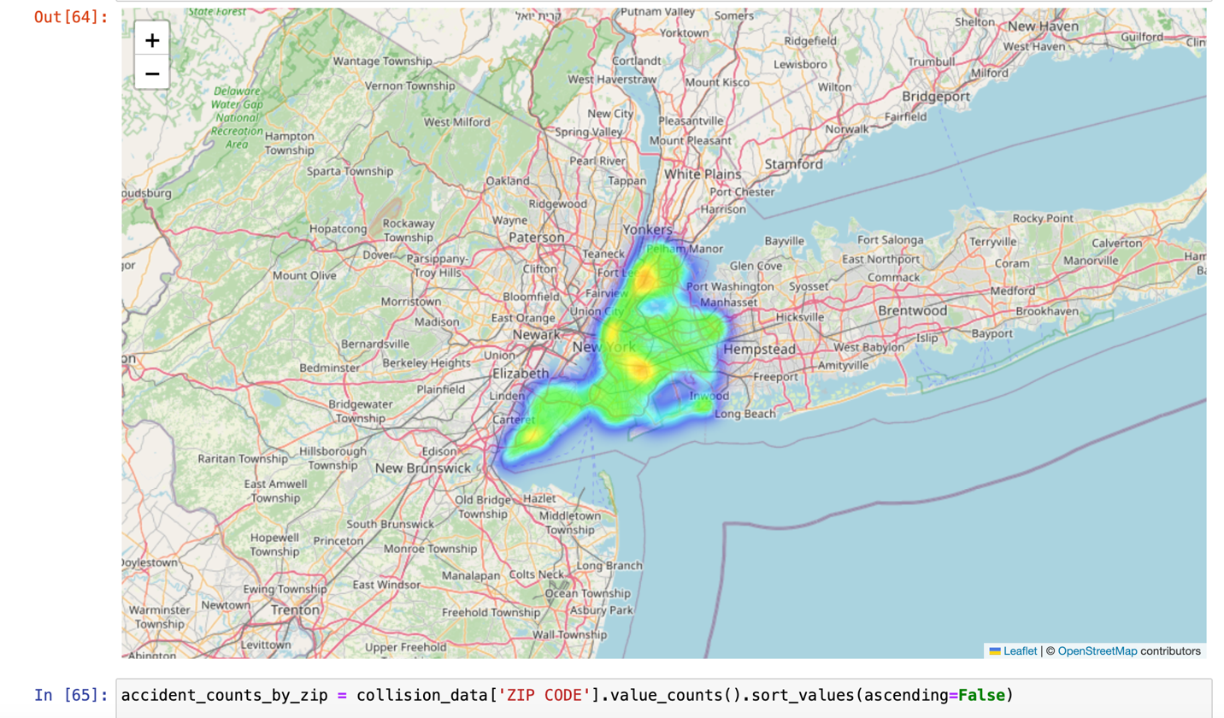

The Geo heatmap of New York presents a visualization of traffic incidents, providing a powerful demonstration of the regions within New York where roadside emergencies are most common. This data is particularly relevant for SafeDrive Essentials, indicating potential areas of high demand for emergency kits.

Recommendations:

Market Entry:

Location-Based Marketing: Leverage the heatmap data to target areas in New York with higher frequencies of road incidents. These locations are prime markets for the initial rollout of SafeDrive Essentials.

Partnerships: Establish partnerships with local automotive shops, insurance companies, and driving schools in New York, especially within the high-incidence areas shown in the heatmap.

Product Development:

Kit Composition: Based on the sentiment analysis, ensure that the emergency kits include highly sought-after items that address the common concerns and needs expressed in consumer feedback.

Customer Engagement: Encourage detailed customer feedback through follow-up surveys or incentives to provide more substantial data for sentiment analysis, ensuring continuous product improvement.

Awareness & Education:

Campaigns: Implement educational campaigns in high-incident areas to raise awareness about the importance of being prepared for road emergencies.

Community Involvement: Get involved in local community safety programs and workshops to promote the SafeDrive Essentials brand and educate consumers.

Expansion:

Growth Strategy: After establishing a strong presence in New York, plan to gradually expand to other states, prioritizing areas with similar patterns of road safety incidents.

Data-Driven Scaling: Utilize ongoing data analysis, similar to the New York heatmap, to inform the expansion strategy, identifying areas with the greatest need for roadside emergency kits.

Online Presence:

E-commerce: Develop an online presence that allows consumers to purchase kits directly. Offer detailed product information, customer reviews, and educational content on road safety.

Social Media: Utilize social media platforms to engage with customers, share safety tips, and provide updates on product offerings.

By focusing on data-driven decisions, customer engagement, and continuous product improvement, SafeDrive Essentials can successfully enter and capture the market for roadside emergency kits, starting from the bustling streets of New York.

Reference:

* <https://www.amazon.com/WETBAS-Emergency-Assistance-Essentials-Reflective/dp/B09QXJF7C5/ref=sr_1_1?crid=1DZ5QP5JYTLJ8&dib=eyJ2IjoiMSJ9.h_0E2ca5uJLYaOfmD9hJZFrCUw75q7M_F6P6xiQRRRnySpxpBLMbenDqgaQ--f7T5nE9MucWWGOFT0kkqSkn9qajEUhJxmHPJXHHivUD6Zt0hnxlixWPi61LWXno5TKsFdtoIU0YuAnhN6L4smSZxaALGFAmtCOFqJAzDV7J3VgWWcWsle-B-VrGmF_LZ8Q3xtcdFOkMxzjGwkrZijiR5usWuzf6TVE525ap5LwAPuFFu4URXffWrfQSVj3rDgb3DyA4MCEHebf11RhPDwDrmDY0gxoaAoCURLOesOgE2oQ.NtLs37yYHCc9nK-G8nfgOYW71OhnbS5MSNdE5NC_kbE&dib_tag=se&keywords=vehicle+safety&qid=1714508962&sprefix=vegicle+safet%2Caps%2C389&sr=8-1>
* <https://github.com/SadiMahfuz/620-Project>
* https://realpython.com/python-web-scraping-practical-introduction/